**Smart Education Events System (SEES) Project Report**  
**Date:** 2025-02-04  
**Team Members:**

* Georges Ghazal- 40231026- Full-Stack developer-Project Manager: chose technologies used
* Peter Samaha - 40238955 – Back-End developer-Database administrator : project definition
* Samer Hasna - 40234608 – Front-End developer-AI integration specialist : Context diagram
* Boudy Joe Samaha - 40238965 – Full-stack developer- Scrum Master : UML diagram

**Table of Contents**

1. Project Definition
   * Objectives
   * Methodology and Member Responsibilities
   * Elements and Deliverables of the Project
2. Problem Definition
   * Problem Statement and Emergence
   * Proposed Solution and its Advantages
3. Technology Used
   * Tools for Collaboration, Monitoring, Design, and Coding
4. Context Diagram
5. Domain Model
6. Conclusion

* 1. Project Definition
* Objectives  
  The primary objective of this project is to develop a smart and efficient event management system tailored specifically for educational institutions. The system aims to streamline the organization, scheduling, and coordination of educational events while enhancing engagement between event organizers and attendees. Key goals include:
* Developing an automated event management platform to handle scheduling, notifications, and attendee coordination seamlessly.
* Improving interaction and engagement between event organizers, educators, students, and other participants.
* Implementing AI-driven chat assistance to provide real-time support and query resolution for users.
* Enabling seamless communication through automated email notifications, ensuring participants are always informed about event details and updates.
* Providing data analytics and reporting tools to assess event performance and enhance future event planning.
* Enhancing networking opportunities by integrating features that facilitate participant connections and collaboration.
* Methodology and Member Responsibilities  
  The development of this system follows an agile methodology, ensuring flexibility and iterative improvements throughout the project lifecycle. The team is structured as follows:
* Project Manager: Oversees the entire development process, ensures timelines are met, and coordinates team efforts to maintain efficiency.
* Frontend Developer: Designs and develops an intuitive user interface using React and Node.js, ensuring accessibility and responsiveness.
* Backend Developer: Implements and maintains API endpoints, manages database operations with MongoDB, and ensures secure data handling.
* AI Integration Specialist: Works on implementing AI chatbot functionality using OpenAI's API to enhance user support and event assistance.
* Database Administrator: Designs the data schema, optimizes queries, and ensures secure data storage and retrieval.
* Elements and Deliverables of the Project  
  This project will deliver a robust and user-friendly event management system that includes the following core components:
* A fully functional event management system with role-based access for administrators, organizers, and attendees.
* A modern frontend interface developed using React and Node.js, ensuring an intuitive and seamless user experience.
* A secure backend architecture utilizing Express.js and MongoDB to manage event data efficiently.
* An AI-powered chatbot assistant that helps users with event-related queries, improving engagement and accessibility.
* Automated email notifications powered by Twilio SendGrid to keep users informed about event updates, reminders, and changes.
* Comprehensive system documentation, including a context diagram and domain model, to illustrate system architecture and functionalities.
* 2. Problem Definition
* Problem Statement and Emergence  
  Managing educational events manually presents several challenges, including time-consuming coordination, communication gaps, and difficulty in gathering participant feedback. Many educational institutions struggle with event organization due to a lack of automation, leading to inefficiencies in scheduling and participant engagement. Furthermore, existing event management solutions often fail to cater specifically to the needs of academic environments, either being too costly or lacking necessary educational integrations.
* Proposed Solution and Its Advantages  
  Our solution aims to address these issues by providing an intelligent, automated, and cost-effective event management system. Key advantages include:
* Automation of Event Planning: Reduces manual workload by automating scheduling, reminders, and updates.
* AI Chat Assistance: Provides real-time query resolution, enhancing user experience and engagement.
* Seamless Email Notifications: Keeps attendees informed about event details, reducingmiscommunication.
* Data-Driven Insights: Offers analytics and reporting features to evaluate event success and improve future planning.
* Enhanced Networking Opportunities: Facilitates connections among attendees, creating a collaborative academic environment.
* 3. Technology Used
* Tools for Collaboration, Monitoring, Design, and Coding  
  To ensure efficient development, collaboration, and deployment, we are utilizing the following technologies:
* Frontend Development: React and Node.js for building an interactive and responsive user interface.
* Backend Development: Express.js and MongoDB for handling data storage, retrieval, and API interactions.
* Collaboration & Version Control: GitHub for source code management, version control, and team collaboration.
* Project Management: GitHub Issues for tracking tasks, assigning responsibilities, and monitoring progress.
* Design & UI Prototyping: Figma for creating wireframes and user interface designs, ensuring a visually appealing and user-friendly experience.
* AI Integration: OpenAI API for implementing AI chat functionality, enhancing event-related user support and engagement.
* Email Service: Twilio SendGrid for sending automated emails related to event updates, confirmations, and reminders.
* By leveraging these technologies, our system ensures a seamless, secure, and scalable solution for educational event management. The integration of AI assistance, automation, and data-driven insights makes this platform a comprehensive tool for institutions looking to enhance their event organization capabilities.

**4. Context Diagram**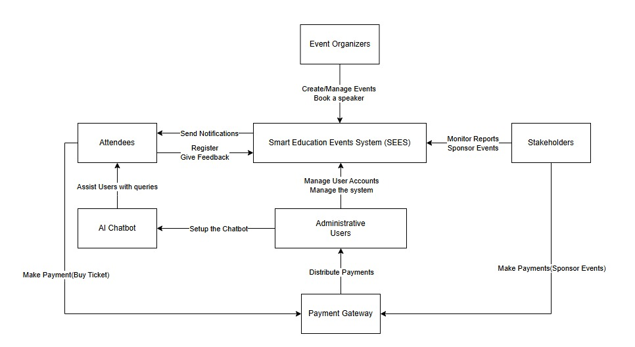

**

**6. Conclusion**

The Smart Education Events System (SEES) is designed to modernize and simplify the process of organizing educational events. By integrating automation, AI chat assistance, and real-time analytics, SEES enhances the experience for organizers and attendees alike. The implementation of email notifications and an intuitive user interface ensures smooth communication and accessibility. This project lays the foundation for an efficient, scalable, and smart event management solution.